**SAP Summer School**

Setup

internal

1. Installation Guide
   1. Connect to an SAP system
   2. Install Eclipse
   3. Install ADT (ABAP Development Tools)
2. Transactions

# Installation Guide

## Connecting to an SAP System

In order to enable communication with an SAP Netweaver System, the “SAP GUI” client has to be installed locally on the personal computer. In the “SAP Logon” (which is part of the SAP GUI installation) connection settings for multiple SAP Systems can be entered, which are then used to establish a connection to those systems.

Steps:

1. On your computer, click the start button and search for “SAP Logon”



2. Click the “New” Icon to add a new system

3. Select “User specified system” & NEXT

4. Fill in the details of the new system:

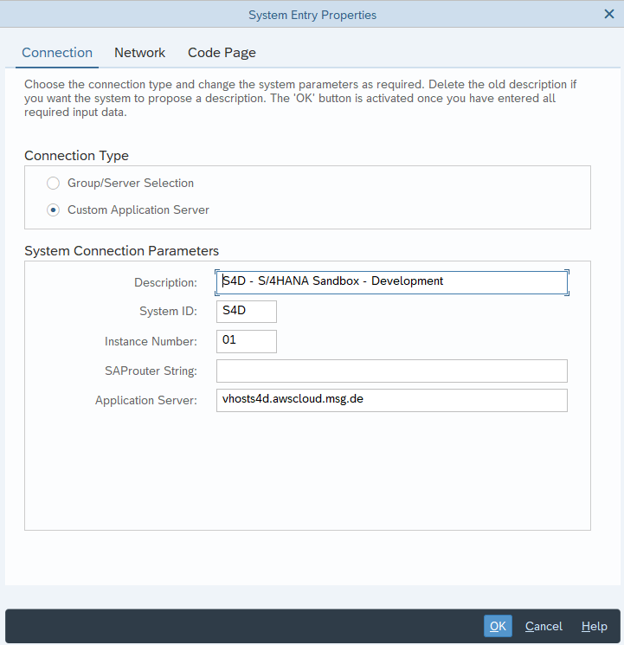

a. Connection Type: Custom Application Server

b. Description: “S4D”

c. Application Server: vhosts4d.awscloud.msg.de

d. Instance Number: 01

e. System ID: S4D

5. Click on “Finish”

6. “S4D” should now appear in your system list.

7. Double-clicking it will bring up the logon page, enter your logon details:

a. Client: 200

b. User: <XXX>

c. Password: TBD

d. Logon language: EN

8. If you change your password, make sure you write it down

## Install Eclipse

* Download link for Eclipse IDE 2023-06 (latest) <https://www.eclipse.org/downloads/>
* Important: Install Eclipse without intranet cable and without VPN

## Install ADT (ABAP Development Tools)

1. Install ADT

* Open eclipse and select *Help > Install New Software*:

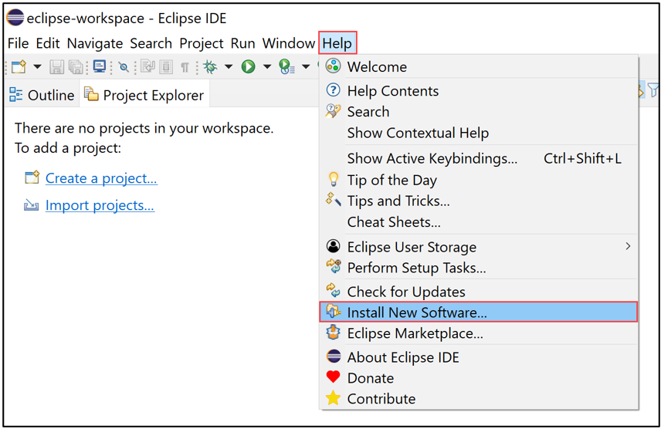

* Enter the latest ADT URL *https://tools.hana.ondemand.com/latest* in the *Work with* section, press enter, select all available options:

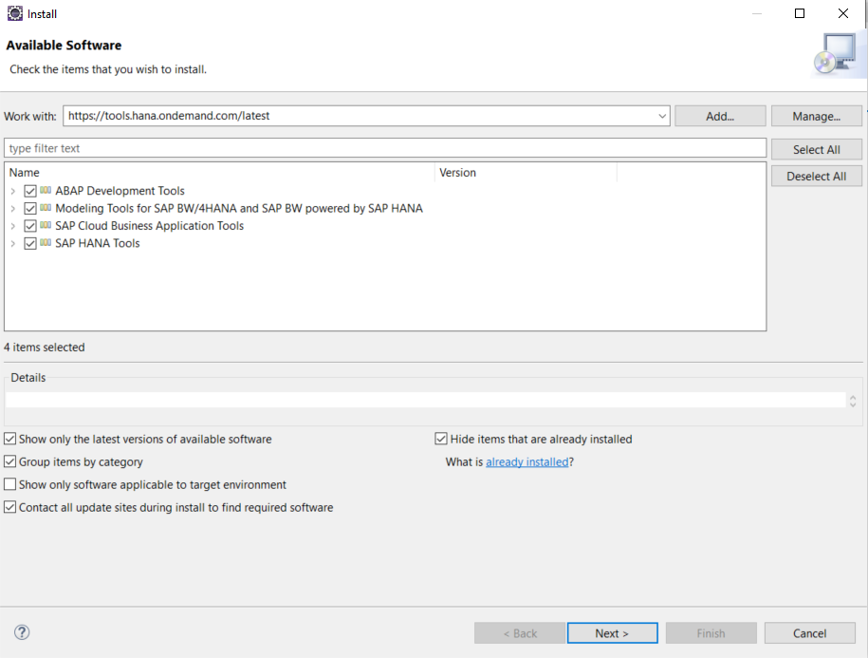

* Accept the license agreement and click Finish:

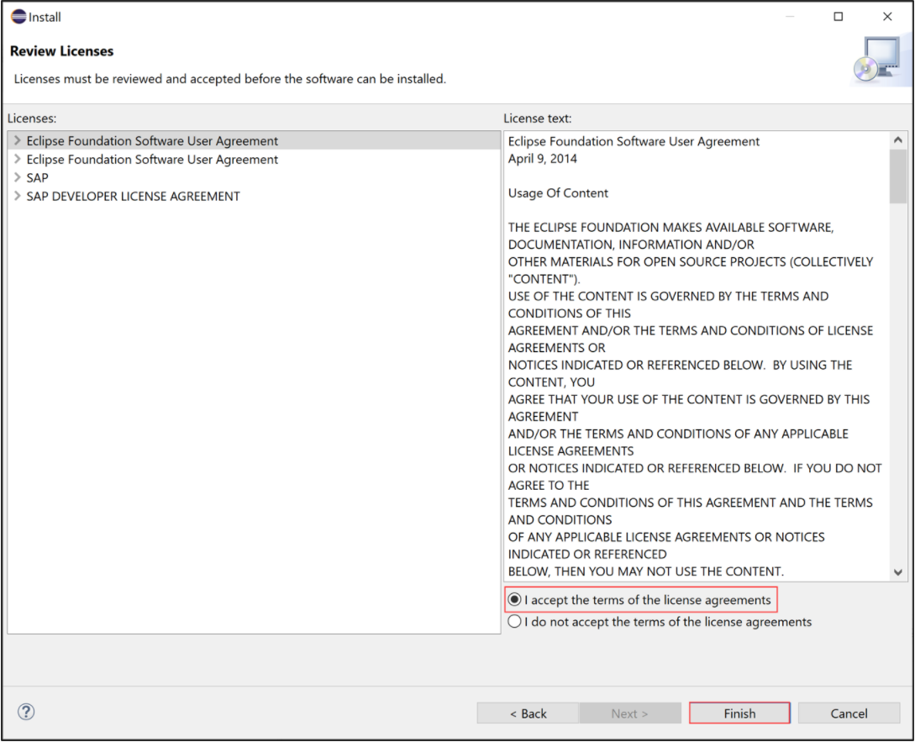

* Now the ADT will be installed. Select Install anyway.
* Click Select All and Accept selected:

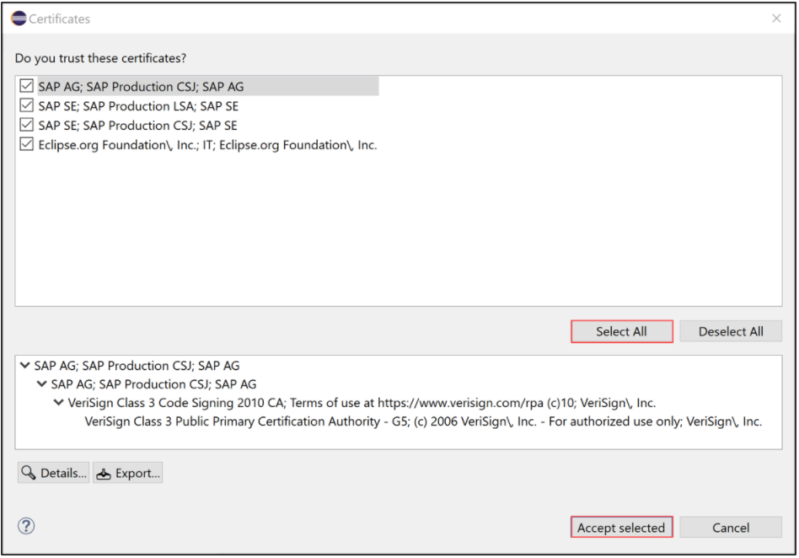

* Click Restart Now.
* Now ADT is installed. Switch to the ABAP perspective. Therefore, select Window > Perspective > Other Perspective > Other:

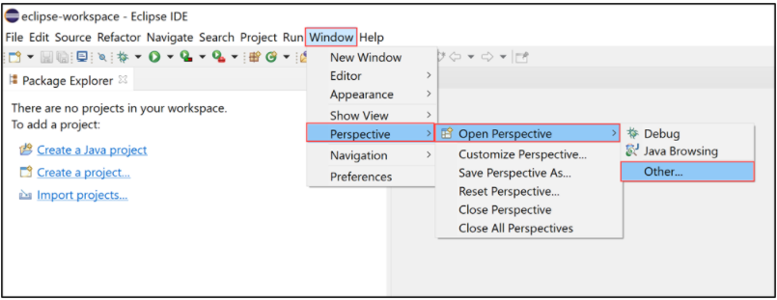

* Then select ABAP and click Open:

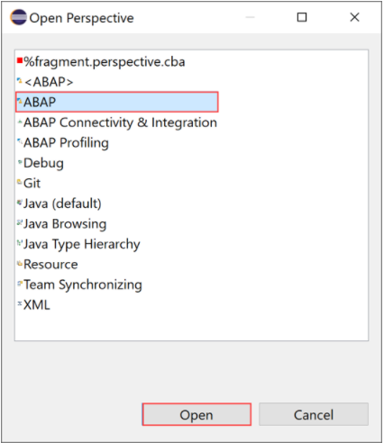

1. In Eclipse an ABAP project has to be created for the system S4D (New -> Project -> ABAP -> ABAP Project).
2. Common agreed Eclipse Settings

* ABAP Formatter (aka Pretty Printer)

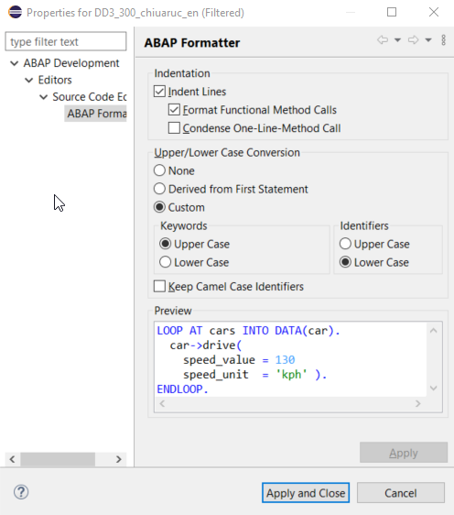

* Code Completion

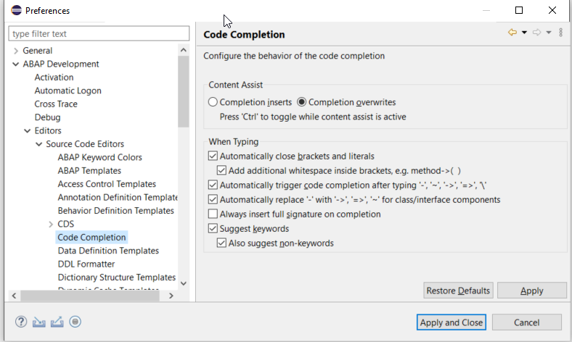

# Transactions

Simply put, transactions can be viewed as shortcuts used for starting up applications on the Netweaver Application Server. Every transaction has a unique transaction code (most commonly composed of 4 alphanumeric characters)

Transaction codes can be entered in the upper left input box. Additionally:

• /o<transaction code> opens the transaction in a new session/window

• /n<transaction code> stops the transaction running in the current session/window, and starts the one identified by <transaction code>

Steps:

1. As a first test, start the transaction “SM04”, which displays every user currently logged on in the system. What programs are the users currently executing?

2. In a new session, start the Object Navigator (Transaction “SE80”). This is your central entry point to the ABAP Development Workbench

3. When the Repository Browser is open in the Object Navigator, all packages, global classes, programs etc. available in the system can be looked up and opened using the input fields highlighted below

4. Change the look of the SAP GUI -> in case of S4H set it from: MORE/OPTIONS/GUI OPTIONS. After setting the theme, restart your session.

5. Set the pretty printer:

